Modern Education Society's

NOWROSJEE WADIA COLLEGE, PUNE
(An Autonomous Institute Under Savitribai Phule Pune University )
Department Of Computer Science
M.Sc. (Computer Science) Part II Sem – III
2025 - 2026
A Research Project Report On
“Indian Sign Language Translation System”

Submitted By –
- Dnyaneshwari Eknath Kauthale
- Snehal Sambhaji Labade
Under The Guidance Of –
Asst Prof. Sayali Patil

Internal Examiner External Examiner

Certificate

This is certified that the student Kauthale Dnyaneshwari, Roll No.21 has successfully completed the Research Project work of Sem- III of M.Sc. Part II in the academic year 2025-26.

Internal Evaluation:

Description | Marks  (out of) | Marks Obtained
Research topic / Problem /Survey | 10
Literature review and/or Data collection | 10
Presentation and Documentation | 10
Total Marks | 30

Sign of Research Project Guide /Expert:

Certificate

This is certified that the student Labade Snehal , Roll No. 25 has successfully completed the Research Project work of Sem- III of M.Sc. Part II in the academic year 2025-26.

Internal Evaluation:

Description | Marks  (out of) | Marks Obtained
Research topic / Problem /Survey | 10
Literature review and/or Data collection | 10
Presentation and Documentation | 10
Total Marks | 30

Sign of Research Project Guide /Expert:

Sr. No. | Title | Page No.
1. | List OF Figures | 5
2. | List OF Tables | 5
3. | Abstract | 6
4. | Introduction  - Objectives Of Research  - Methodology | 7  8  8
5. | Literature Review | 13
6. | Data collection | 17
7. | Actual Work Done with Experimental Setup | 19
8. | Results | 20
9. | Future Scope Of The Project | 21
10. | Conclusion | 22
11. | Bibliography / References | 23
Index

- List Of Figures
Sr. No. | Name of Figures | Page No.
1.
2.
3.
4.
5.
6.

- List Of Tables
Sr. No. | Name of Tables | Page No.
1.
2.
3.
4.
5.
6.

- ABSTRACT
Indian Sign Language (ISL) recognition has emerged as a critical research area for developing assistive communication technologies that bridge the gap between Deaf and hard-of-hearing individuals and the hearing population. This paper presents a comparative analysis of three fundamental neural network architectures namely Feed-forward Neural Network(FNN), Convolutional Neural Network(CNN), and Long Short-Term Memory (LSTM) Network on a static image dataset of ISL alphabet. Findings indicate that FNN acts as a simple lightweight benchmark, whereas CNNs are superior in spatial feature extraction for static gestures. Further, the study also explores application of LSTMs on static pixel sequences to evaluate its feasibility. Comparing all these three neural network architectures, this study concludes that although CNN works best for static dataset, the limitations of static images require a shift towards dynamic, real-time video dataset for future implementation.

- Introduction
Indian Sign Language (ISL) is a visual gestural language that conveys meaning through coordinated hand movements, facial expressions, and body posture. Despite its central role within the Deaf community in India, communication with non-signers remains constrained by the limited availability of trained interpreters and the lack of scalable assistive technologies, particularly in public, educational, and healthcare services resulting in the social and professional isolation of the deaf community[1], [2].
Computer-vision-based Sign Language Recognition (SLR) has become an important field of study to fill this gap. ISL remains comparatively less explored in AI research, due to its regional variations and lack of standardized, large-scale dynamic datasets, whereas American Sign Language (ASL) has been thoroughly documented. Most of the existing systems still use static images, which provide a starting point but fail to capture the fluid, dynamic motion dependent nature of real time communication.
This research addresses the static bottleneck by conducting a comparative study of three fundamental neural networks architectures FNN,CNN, and LSTM using a publicly accessible static ISL dataset. The spatial feature extraction capabilities of CNNs are compared against the sequential processing of LSTMs. The primary contribution of this study is to establish a high accuracy baseline for static alphabet recognition by providing the empirical justification for transition toward dynamic, real time video communication.
The paper is organized as follows. Next section 2 is primarily focused on literature review and related work. Section 3 presents the System architecture and Methodology followed by result and discussion presented in section 4. The paper ends with a conclusion and future scope.

Objectives Of Research
• To benchmark the performance of Feedforward Neural Network (FNN), Convolutional Neural Network (CNN), and Long Short-Term Memory (LSTM) models on static Indian Sign Language (ISL) alphabet datasets.
• To evaluate the effectiveness of spatial feature extraction (CNN) versus temporal sequence modeling (LSTM).
• To analyze deployment trade-offs between lightweight architectures (FNN), robust vision-based models (CNN), and sequential models (LSTM).
• To establish a high-accuracy baseline for static ISL alphabet recognition and justify the transition toward dynamic, real-time video datasets.
• To support the development of scalable, low-cost assistive communication technologies for bridging the gap between Deaf and hearing communities.
• To lay the foundation for integration with Natural Language Processing (NLP) and Text-to-Speech (TTS) systems, enabling sentence-level translation and real-time communication

Methodology
System architecture and methodology
The low-dimensional hand-landmark vectors that are taken from RGB frames, usually representing the joint coordinates of fingers and palms are used by the FNN pipeline. Before generating predictions at the alphabet level,these flattened feature vectors are passed through a number of fully connected layers with non-linear activations.Such architectures are computationally efficient and suitable for controlled environments; however, they do not explicitly encode spatial relationships among finger joints and are sensitive to landmark noise and occultations, as noted in recent landmark-centric ISL systems and lightweight translation frameworks [3], [10].
The CNN based pipeline, on the other hand, uses stacked convolutional layers and pooling operations to learn hierarchical spatial representations of palm geometry and finger configurations after directly processing cropped RGB hand images. Local receptive fields enable the convolutional neural network (CNN) to capture fine details of shape, relationships between fingers, and texture variations. These features are crucial for distinguishing visually similar alphabet gestures. After extraction, the feature maps are flattened and then sent to fully connected layers, which perform the final letter classification.Compared with landmark-driven FNNs, CNN architectures generally exhibit improved robustness to background variation, viewpoint changes, and minor pose inconsistencies, making them more suitable for vision-based ISL alphabet recognition in unconstrained settings, as supported by comparative evaluations in recent translation-oriented studies [4], [5]. Fig.1 depicts the structural difference between FNN and CNN architectures for ISL alphabet recognition.

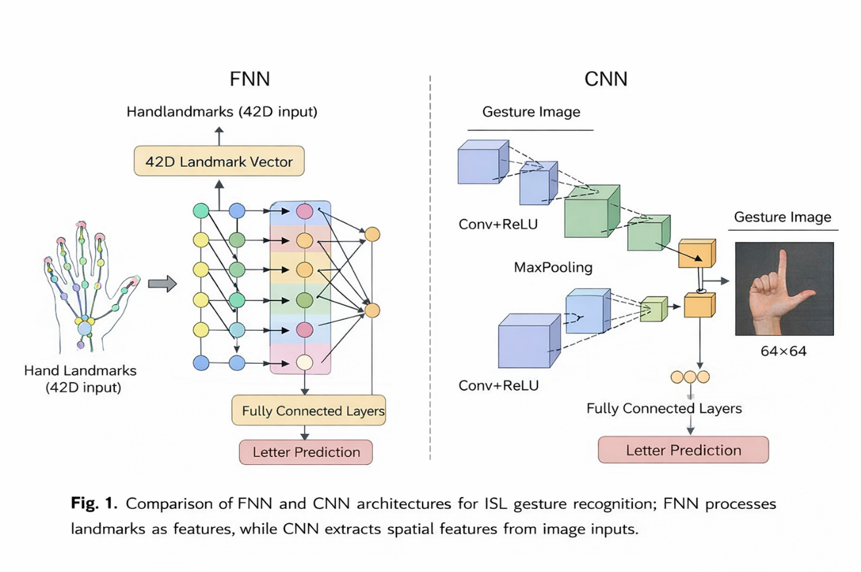
Fig. 1. Comparison of Feedforward Neural Network (FNN) and Convolutional Neural Network (CNN) architectures for Indian Sign Language (ISL) alphabet recognition.
A feedforward neural network (FNN) using 42 normalized hand-landmark coordinates taken from RGB video frames is used in the current ISL recognition system. A softmax output layer that generates probabilities across 35 gesture classes comes after four gradually decreasing dense layers interspersed with dropout regularization (rate 0.5) to prevent overfitting.The network contains approximately 1.77 million trainable parameters and performs frame-wise classification without explicit temporal modeling [11],[12]. Table 2 shows FNN architecture used in the existing landmark-based ISL recognition system.
Table 2. Architecture of the existing FNN system
Layer No. | Layer Type | Configuration | Output Size | Trainable Parameters
0 | Input | 42 hand-landmark features | (42) | 0
1 | Dense | 1470 units, ReLU | (1470) | 63,210
2 | Dropout | Rate = 0.5 | (1470) | 0
3 | Dense | 832 units, ReLU | (832) | 1,223,872
4 | Dropout | Rate = 0.5 | (832) | 0
5 | Dense | 428 units, ReLU | (428) | 356,324
6 | Dropout | Rate = 0.5 | (428) | 0
7 | Dense | 264 units, ReLU | (264) | 113,256
8 | Dropout | Rate = 0.5 | (264) | 0
9 | Output Dense | 35 units, Softmax | (35) | 9,275
— | Total | — | — | 1,765,937
While a standalone feedforward neural network operating on hand-landmark vectors is sufficient for baseline alphabet-level recognition under controlled acquisition conditions, such architectures lack explicit modeling of spatial relationships among joints. Table 2 and Table 3 provide an overview of the architectural difference between the proposed CNN classifier and the landmark-based FNN, with particular attention to layer depth and activation functions.
Table 3. CNN Architecture Parameters for Landmark Input
Layer No. | Layer Type | Configuration / Description | Output Size | Trainable Parameters
0 | Input | 42 reshaped hand-landmark features | (42, 1) | 0
1 | Conv1D | 32 filters, kernel size = 3, ReLU | (40, 32) | 128
2 | MaxPooling1D | Pool size = 2 | (20, 32) | 0
3 | Conv1D | 64 filters, kernel size = 3, ReLU | (18, 64) | 6,208
4 | MaxPooling1D | Pool size = 2 | (9, 64) | 0
5 | Flatten | Feature vector generation | (576) | 0
6 | Dropout | Rate = 0.5 | (576) | 0
7 | Dense | 128 units, ReLU | (128) | 73,856
8 | Dropout | Rate = 0.5 | (128) | 0
9 | Dense (Output) | 35 units, Softmax | (35) | 4,515
— | Total | — | — | 84,707
By introducing localized receptive fields that capture structural dependencies between nearby landmarks and finger groups, convolutional layers enable hierarchical spatial feature learning and enhance detection jitter robustness. Convolutional encoders also improve generalization by reducing parameter redundancy in comparison to large fully connected layers. By taking advantage of short-term temporal context between successive frames, these representations further improve recognition stability for dynamic gestures when paired with recurrent sequence models.

5. Literature Review and Related Work
Research on Indian sign Language (ISL) recognition has expanded significantly in recent years, driven by growing demand for automated assistive communication technologies. Existing work spans a broad range of architectural paradigms, including landmark-driven classifiers, convolutional neural network (CNN) based visual encoders, and hybrid spatio-temporal learning frameworks. This section reviews representative approaches reported in the literature, summarizes their limitations, and outlines research directions motivating further investigations.
5.1 Architectures based on Vision in Existing Literature
The majority of modern ISL recognition systems use multi-stage pipelines that include video capture, feature extraction, classification, hand or pose detection, and output generation [3-5].Recent studies have increasingly integrated temporal modeling over spatial features to handle dynamic gestures and limited continuous signing, allowing for sequence-level analysis instead of independent frame-wise prediction [6-8].
5.2 Limitations in Current ISL Recognition Systems
Despite continuous improvement, existing ISL recognition systems still struggle with issues such as rapid hand motion, transitional poses, occlusion, and frame-wise instability [6],[7]. CNN based techniques frequently call for larger labeled datasets and more computational resources , while landmark based pipelines might overlook subtle visual cues [8],[9]. Furthermore, a number of open source implementations are still limited to isolated alphabet recognition without stabilization or linguistic post-processing modules [12-14], and many systems are only tested in controlled environments with a restricted signer diversity, which limits real world generalizations.
5.3 Hybrid Spatio-Temporal Models in Prior Studies
To overcome limitations of the landmark-only pipelines, several studies adopt hybrid visual temporal architectures that integrate CNN based spatial encoders with sequence models [15], [16]. These approaches have shown strong performance for dynamic gestures and constrained continuous signing, particularly on large-scale datasets such as ISLTranslate and iSign [9], [10]. Recent work further explores Transformer-based and attention-driven models for long-range temporal reasoning [17], [18]; however, their high data computational demands limit suitability for real-time or edge deployment [19],[20].
5.4 Open Problems and Motivating Research Directions
The literature identifies persistent challenges in ISL recognition, including signer variability, background clutter, rapid motion,two-hand coordination, and modeling of non-manual cues such as facial expressions and body posture [4], [12], [13].Scalability to sentence-level translations and tighter integration with NLP modules also remains open research directions [17-19].Recent trends emphasize the need for architectures that balance spatial richness, temporal modeling, and computational efficiency while supporting modular deployment and standardized evaluations [4], [5], [20].
5.5 Evolution of Sign Language Recognition Systems
In the early days, Indian Sign Language recognition systems often followed a sensor based or IoT enabled acquisition system including wearable gloves,which provided higher accuracy in gesture detection but came along with some limitations in terms of higher costs of hardware,complexity in terms of calibration,restricted movement, and poor scalability of the system for public usage[3],[13],[20].However, in the current research work, the system has been developed based on a purely vision-based system without the need for any specific sensors, which provides the advantage of higher robustness through deep spatial temporal modeling[5],[12].The proposed system has the advantage of overcoming the various deployment challenges of the system by leveraging the advantages of convolutional feature extraction, temporal sequence modeling and stabilization through software based techniques, which are likely to provide a low-cost, portable and more scalable solution for sign-to-text translation in the Indian environment[14],[15],[21].
5.6 Comparative Summary of Existing Systems
Table 1 presents a comparison of selected ISL recognition frameworks reported in the literature, highlighting sensing modalities, learning architectures, and reported objectives for real-time gesture interpretation.
Table 1. A brief comparison of vision-based ISL recognition systems
Ref. | Author(Year) | Data Acquisition | Dataset / Task | Features / Classifier | Key Outcome / Note
[4] | Selvaraj et al. (2021) | RGB (Pose) | ISL gestures | Pose-based pretrained models | Low-resource pose-centric ISL recognition
[5] | Subramanian et al. (2022) | RGB | ISL gestures | MediaPipe Holistic + GRU | Optimized real-time landmark-based ISL recognition
[6] | LiST Framework (2022) | RGB + Multimodal | Continuous ISL | InceptionV3 + LSTM | High-accuracy multimodal ISL translation
[8] | Acadlore (2023) | RGB | Dynamic ISL | LSTM | Effective temporal modeling for gestures
[12] | Pandey et al. (2025) | RGB | Continuous ISL | CNN + LSTM + Transformer | Hybrid temporal modeling for CSLR
[17] | Kamble et al. (2025) | RGB | ISL gestures | LSTM + MediaPipe | Real-time webcam-based recognition
[20] | Damdoo & Kumar (2025) | Survey | Multi-task ISL | Survey of deep models | Comprehensive architectural review
[21] | Anonymous (2025) | RGB | ISL gestures | CNN + MediaPipe | High-accuracy alphabet-level detection
Table 1 shows a clear progression from handcrafted and sensor-driven systems toward vision-based deep learning pipelines that incorporate CNNs, pose estimation frameworks, and temporal modeling modules. Although such architectures have proved to be remarkably effective for alphabet-level and constrained continuous-signing scenarios, unresolved challenges related to sentence-level translation, non-manual feature modeling, and real-world robustness persist across current research efforts.
These findings encourage more research into modular and scalable architectural designs that can facilitate real-time sign-to-text translation and generalize to a variety of settings and users.

6. Data Collection

Dataset Description
- Dataset: Static ISL alphabet images sourced from Kaggle.
- Source Dataset: 42,700 images across 35 classes (1-9, A-Z) from Indian Sign Language
Fig. 2. Vision-Based ISL Alphabet Dataset Sample

Fig. 2. shows a representative isolated alphabet gesture from a vision-based ISL dataset recorded using an RGB camera. Such samples are commonly used for training and evaluating alphabet-level sign recognition models under controlled conditions [21-23].
Pipeline:
- Keypoint Extraction: MediaPipe is used to detect 21 hand landmarks from each image, resulting in 42 coordinate values (x and y position) that represent the hand structure.
- Normalization: The extracted landmark coordinates are automatically normalized to a range of [0, 1] by Mediapipe. This helps ensure consistency and improves model training stability.
- Storage: The processed landmarks features are stored in a structured file named keypoint_small_csv, which contains 15,336 samples for training and evaluation.

Model Input:
- FNN: The landmark coordinates are flattened into a one-dimensional feature vector consisting of 42 input features
- CNN: The same landmarks data is reshaped into a(42 × 1) sequence format, allowing the convolutional layers to learn spatial relationships between neighboring landmarks.
- LSTM: The landmark sequence is treated as 42 sequential time steps with one feature per step, enabling the model to learn sequencing patterns within the landmark structure.

7. Actual Work Done with Experimental Setup

Pipelines Implemented
- Feedforward Neural Network (FNN)
  - Input: 42 normalized hand-landmark coordinates extracted using MediaPipe.
  - Architecture: Four dense layers with dropout (rate 0.5) and a softmax output layer.
  - Parameters: ~1.77M trainable.
  - Limitation: Sensitive to noise, lacks explicit spatial modeling.
- Convolutional Neural Network (CNN)
  - Input: Landmark data reshaped into (42 × 1) format.
  - Architecture: Conv1D + MaxPooling layers → Flatten → Dense layers → Softmax output.
  - Parameters: ~84K trainable.
  - Strength: Captures local spatial dependencies, robust to background variation and pose inconsistencies.
- Long Short-Term Memory (LSTM)
  - Input: Landmark sequence treated as 42 time steps.
  - Architecture: Sequential recurrent units for temporal modeling.
  - Performance: Moderate on static data, better suited for dynamic gestures.
Workflow Pipeline
- Data Acquisition: Kaggle ISL dataset (42,700 images across 35 classes).
- Preprocessing: MediaPipe used to extract 21 hand landmarks → 42 coordinates normalized to [0,1].
- Storage: Features stored in CSV file containing 15,336 samples for training and evaluation.
- Model Training: FNN, CNN, and LSTM trained on identical dataset splits.
- Evaluation: Models compared using Accuracy, Precision, Recall, and F1-score.

8. Results
The performance comparison presented in Fig 3. Shows that the Convolutional Neural Network (CNN) delivers the best performance across all evaluated metrics, with an accuracy of 98.12% precision of 98.35%, recall of 96.22%, and an FI score of 0.9718. In comparison, the LSTM model attains moderate performance, while the feedforward neural network (FNN) records architectures provide superior discriminative capability for static Indian Sign Language alphabet recognition.
Convolutional Neural Networks (CNNs) demonstrate superior performance in modeling hand structures for ISL alphabet recognition, owing to their capacity to capture spatial features via convolution and pooling operations. Conversely, Feedforward Neural Networks (FNNs) lack the ability to capture spatial features, and Long Short-Term Memory networks (LSTMs) are not ideally suited for static inputs because they are designed for temporal data processing. Furthermore, as evidenced by the data presented in Tables 2 and 3, CNNs outperform FNNs while utilizing a considerably smaller number of trainable parameters, thereby underscoring their enhanced efficiency. In summary, CNNs provide the most effective baseline among the architectures evaluated for static ISL alphabet recognition.
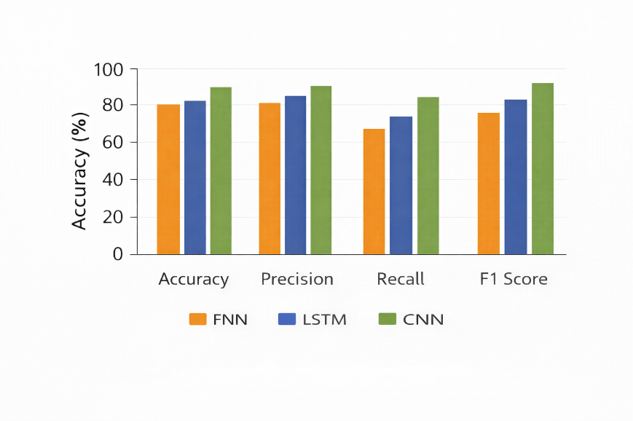
Fig. 3. Model Performance Comparison for Static ISL Alphabet Recognition.
.

9. Future Scope Of Project
The CNN models provide a high accuracy rate on static images, but do not maintain the same level of accuracy for motion-based images. The dynamic characteristics of Indian Sign Language in real-world application make it challenging to accurately distinguish certain signs, such as those for the alphabets J and Z without the context of motion. To address this, future developments will focus on several key areas:
- Linguistic and Regional Development: The primary goal is to broaden the vocabulary to encompass regional dialects of ISL and more intricate sentence constructions, thereby extending beyond the recognition of isolated letters.
- Full sentence translation for real time communication: Continuous Sign Translation Recognition, which replaces isolated sign detection.
- Shift to Real-Time Video Datasets: We propose the creation of a Real-Time dynamic ISL dataset. This will require capturing live motion using standard webcams to effectively represent the fluidity of Indian Sign Language.
- Expanded Vocabulary: The dataset will be enhanced to include regional dialects of ISL and complex sentence structures, thereby advancing beyond the recognition isolated sign.
- Multi-Model Integration: The goal is to combine depth data (RGB-D) with facial expression analysis. This will help identify the non-manual markers that are essential for the complete syntax of Indian Sign Language.

10. Conclusion
This study presented a comparative analysis of Feed Forward Neural Network (FNN), Convolutional Neural Network (CNN), and Long Short Term Memory (LSTM) Networks for the recognition of Indian Sign Language (ISL) using a static image dataset. The findings conclude that CNNs remain the superior architecture for static gesture recognition due to their ability to extract local spatial hierarchies and translation invariant features.
While FNNs are computationally lightweight, and rely on flattened feature representations, they lack explicit spatial modeling capability limiting their effectiveness in capturing the structural complexity of hand gestures. LSTMs show moderate performance when applied to static images but remain structurally underutilized, because static images do not provide the temporal dependencies these networks are designed to model. Although competitive accuracy was achieved on static image datasets, this study also highlights a broader tendency within ISL research to emphasize static benchmarks, even though real world sign language is inherently dynamic and temporally structured.

11. Bibliography / References
1. Tripathi, A., et al. Continuous Indian Sign Language Gesture Recognition and Sentence Formation. Procedia Computer Science, 2015.

2. Roy, A., et al. Position and Rotation Invariant Sign Language Recognition Using 3D Kinect and RNN. arXiv preprint, 2020.

3. Badhe, P. C., and V. Kulkarni. Artificial Neural Network Based Indian Sign Language Recognition Using Hand Crafted Features. Proceedings of the 11th International Conference on Computing, Communication and Networking Technologies (ICCCNT), 2020.

4. Selvaraj, P., et al. OpenHands: Pose-Based Pretrained Models for Indian Sign Language Recognition. arXiv preprint, 2021.

5. Subramanian, B., et al. An Integrated MediaPipe-Optimized GRU Model for Indian Sign Language Recognition. Scientific Reports, vol. 12, no. 1, 2022.

6. Lightweight Sign Language Translation (LiST) Framework for Indian Sign Language. Information, MDPI, 2022.

7. Tripathi, A., et al. Gesture-to-Text Translation Using SURF for Indian Sign Language. Symbiosis Institute of Technology, Pune, India, Mar. 2023.

8. Detecting and Interpreting Indian Sign Language Using LSTM. Acadlore Library, 2023.

9. Joshi, P., et al. ISLTranslate: Dataset for Translating Indian Sign Language. arXiv preprint, 2023.

10. Joshi, P., et al. iSign: A Benchmark for Indian Sign Language Processing. arXiv preprint, 2024.

11. Renuka, and Kumar. Indian Sign Language Recognition Using Deep Learning Techniques. PSG College of Technology, Coimbatore, India, 2025.

12. Pandey, S., et al. Real-Time Vision-Based Indian Sign Language Translation Using Deep Learning Techniques
. International Journal of Innovative Research in Computer Science and Technology, vol. 13, no. 3, 2025, pp. 35–46.

13. Kaliyaperumal, V. G., and P. A. Gopalan. A Deep Neural Network Framework for Dynamic Two-Handed Indian Sign Language Recognition in Hearing and Speech Impaired Communities. Sensors, vol. 25, no. 12, 2025, p. 3652.

14. Sudeshna, S., et al. Speak-to-Sign: A Real-Time NLP Driven Framework for Indian Sign Language Translation—A Review. International Journal of Research in Applied Science and Engineering Technology, June 2025.

15. Gaonkar, A., et al. Real-Time Bidirectional Translation System Between Text and Indian Sign Language Using Deep Learning and NLP Techniques. International Journal of Scientific Research and Engineering Management, Apr. 2025.

16. Khetam, K., et al. Indian Sign Language to Text/Speech Translation Using Deep Learning. D. Y. Patil University, Pune, India, Technical Report, Apr. 2025.

17. Kamble, R., et al. SLRNet: A Real-Time LSTM-Based Sign Language Recognition System. arXiv preprint, June 2025.

18. Indian Sign Language Recognition Using MediaPipe, CNN and LSTM. arXiv preprint, 2025.

19. Mishra, et al. SignSpeak: Indian Sign Language Recognition Using Random Forest and LSTM/LLM. SRS Journal, 2025.

20. Damdoo, R., and P. Kumar. Survey on Indian Sign Language Recognition and Translation. IET Image Processing, 2025.

21. A CNN-Based Indian Sign Language Detection System With MediaPipe Integration for Real-Time Speech/Text Translation. arXiv preprint, July 2025.

22. Varia, Maitree. Indian Sign Language Detection. GitHub, 2025. https://github.com/MaitreeVaria/Indian-Sign-Language-Detection

23. Kumareri, Prathumarikeri. Indian Sign Language (ISL) Alphabet Dataset. Kaggle, 2021. https://www.kaggle.com/datasets/prathumarikeri/indian-sign-language-isl

